Caroline Cliona Boyle

Prof. Minkoff

Data Journalism

February 25, 2022

**Critique: “Facebook groups topped 10,000 daily attacks on election before Jan. 6, analysis shows”**

In The Washington Post’s “Facebook groups topped 10,000 daily attacks on election before Jan. 6, analysis shows,” reporters Jeremy Merrill, Jeff Kao, Craig Silverman and Craig Timberg, conducted regression analyses to determine [over 10,000 posts were made by individuals](https://www.washingtonpost.com/technology/2022/01/04/facebook-election-misinformation-capitol-riot/) part of Facebook groups that fed into far-right extremist ideologies leading up to the Jan.6 attacks. To measure this outcome, The Washington Post created a novel data set in conjunction with ProPublica to investigate the Facebook posts leading up to the Jan. 6 attack on the Capitol. From the regression analysis created by The Post and ProPublica, the publication deduced that Facebook’s algorithm played a significant role in circulating the false narratives leading up to the violence incurred on Jan. 6.

There are two data visualizations in this piece that support the claims of misinformation circulation made by Post reporters. These two visualizations are the primary strengths of this piece, as they do comprehensively represent the trends analyzed by The Post and ProPublica. Firstly, The Post created a bar chart that stems over the course of August 2020 to March 2021 to show that a minimal amount of Facebook groups relating to the Big Lie were removed from the social media site. Trends show that while Facebook removed over 2,000 public U.S.-based Facebook groups related to extremist ideology that support the “Big Lie” the organization removed the majority of groups in spurts that are inconsistent with its actions on Jan. 6. From August 2020 to March 2021, the daily average of group removals ranges from 10 to 25. While there are peaks at 75 removals in September 2020 when Facebook created a task force on misinformation, and 100 removals in October when Facebook announced a ban on all content related to QAnon, the disbandment of the misinformation task force in December 2020 became a catalyst for groups promoting extremist right-wing ideologies to repopulate. This is where inconsistency in Facebook’s efforts to disband right wing groups arises. On Jan. 6, the day of the insurrection, Facebook removed 50 groups, a mere half of the groups that the organization was able to remove leading up to the 2020 election. Shown below, The Post illustrates Facebook’s inconsistency perfectly in this visual.

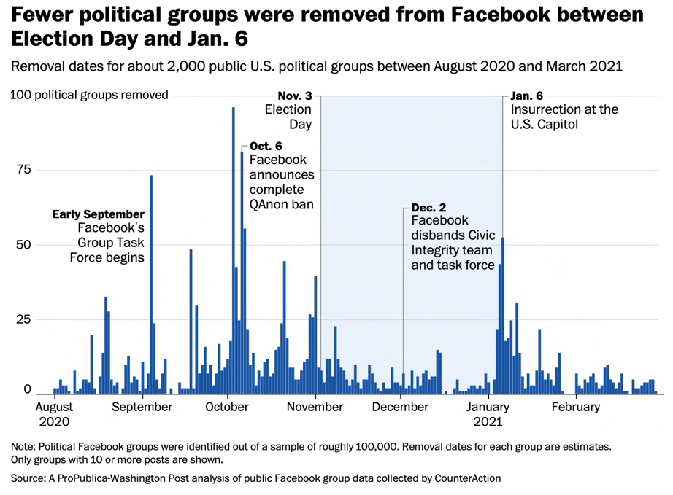

The second visual represented in this piece is a follow up to the data presented in the first, and asserts that Facebook actively chose not to code its algorithm to limit circulation of posts that promoted a false narrative. Presented below, this visual is strong because it illustrates the steady removal of Facebook groups promoting extremist ideology prior to the 2020 election. Facebook groups supporting false narratives peaked in August before the organization instilled restrictions for QAnon groups, with a stark drop off after this point. However, it would have been useful for The Post to continue to maintain consistency between the timelines of the visuals. Consistency between the two visuals would have yielded a better comparison from the removal of groups, and Facebook’s algorithmic choices to circulate the “Big Lie” posts made in these groups.

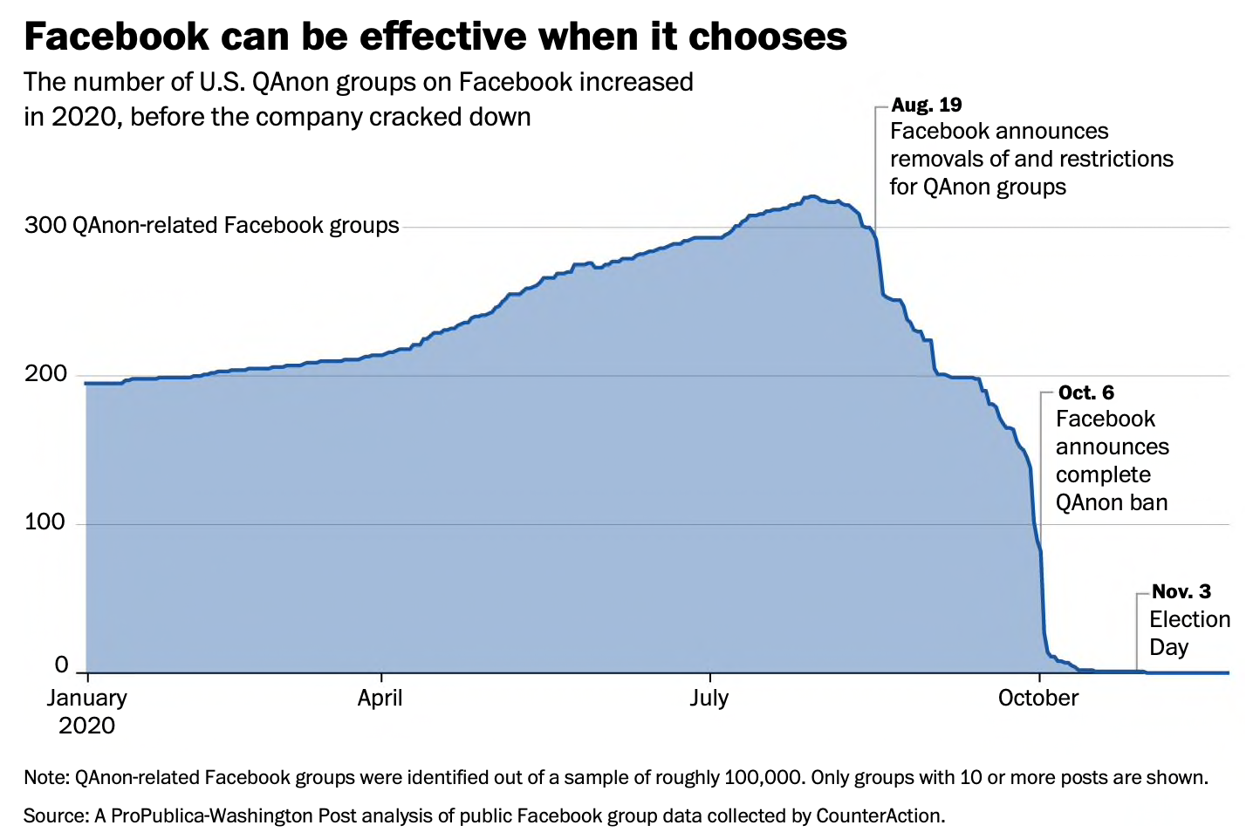

An additional weakness of this piece is that The Post did not create a visual for the top-line message presented, that over 10,000 posts were made by individuals’ part of far-right extremist Facebook groups leading up to the attacks. This is surprising, as typically the top-line information presented in a story where data visualizations are present, would usually include a visual that supports the “most important” information.

In terms of the two graphs presented, the primary challenge in creating visuals for this piece lies in [the methodology](https://www.washingtonpost.com/technology/2022/01/04/facebook-propublica-post-jan6-methodology/) that The Post used to create the data visuals. The difficulty posed in compiling data for this report is that the social media platform Facebook, owned by parent company Meta, repeatedly ignored Congressional requests to obtain algorithmic data that would kickstart an internal investigation into the company. This is a setback for Post reporters in terms of accurately deducing the piece’s second claim, that Facebook’s algorithm played a significant role in circulating the false narratives leading up to the violence incurred on Jan. 6. Thus, while the investigation leveraged a massive analysis of Facebook’s existing archive to determine the exorbitant amount of Post’s that fed into the “Big Lie” leading up to the attack on the Capitol, one key piece of information that the Methodology does not mention is that Facebook [allows its users to delete their own archive](https://slate.com/technology/2020/06/facebook-manage-activity-delete-old-posts.html). Supposedly, the company claims to not harbor this information after data is deleted by the individual user.

There are two problems raised by this methodological challenge. A year onward, many users who did not want their names attached to the extremist ideologies that bred large-scale violence deleted their posts associated with the “Big Lie.” If external servers did not capture this data in a separate archive, then there is no way of tracking this data, leaving room for a statistic that is underreported. Secondly, given the fact that a true archive of all Facebook posts related to the “Big Lie” leading up to the Jan. 6 attack is not 100% readily available, The Posts’ assertion that the Facebook algorithm was directly responsible for circulating false narratives is a fairly hefty claim.

Regardless of the latter assertion made by The Post, and the possibility for underreporting in this piece, The Post has conducted an insightful analysis into misinformation circulation leading up to the Jan.6 attack on the Capitol. While the methodology does present certain challenges in determined exact numbers of posts made by individuals who support the false narratives related to extremist ideologies, the bar chart and area visual created by The Post represent accurate depictions of the analyses conducted.